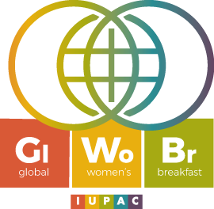

Wednesday 12 February 2020, 9h30
ISIS 6th floor, Campus Esplanade

Join us in the discussion about the role of women in science during the Global IUPAC Breakfast 2020.
We will welcome four scientists with different backgrounds and roles in science to share their experience with us.
Both MEN and women are more than welcome

Program:

9h30 Welcome

Muriel Muzet, Administrative Director of ISIS

Petra Hellwing, Full Professor at Institut Le Bel & Head of UMR7140

Eloïse Devaux, Ingénieur de recherche at ISIS

Fanny Richard, Ingénieur d’études at ISIS

10h30 Breakfast with delicacies from all around the world

Please subscribe before February 5th 2020 by informing your group secretary.

We will be sharing the event on:

