How to register your Global Women’s Breakfast Event
Overall you must first register as an organizer and then add your event(s) to your account. Below are step by step instructions.
Become a registered organizer. Go to https://iupac.org/global-womens-breakfast/
Click on Registration.

Fill out the Primary organizer contact information form, making sure to fill out all the starred fields. Enter and confirm the password you would like to use. Please leave the very last field blank on the form blank as it is for validation purposes, and then click the green button that says “Submit Registration”.
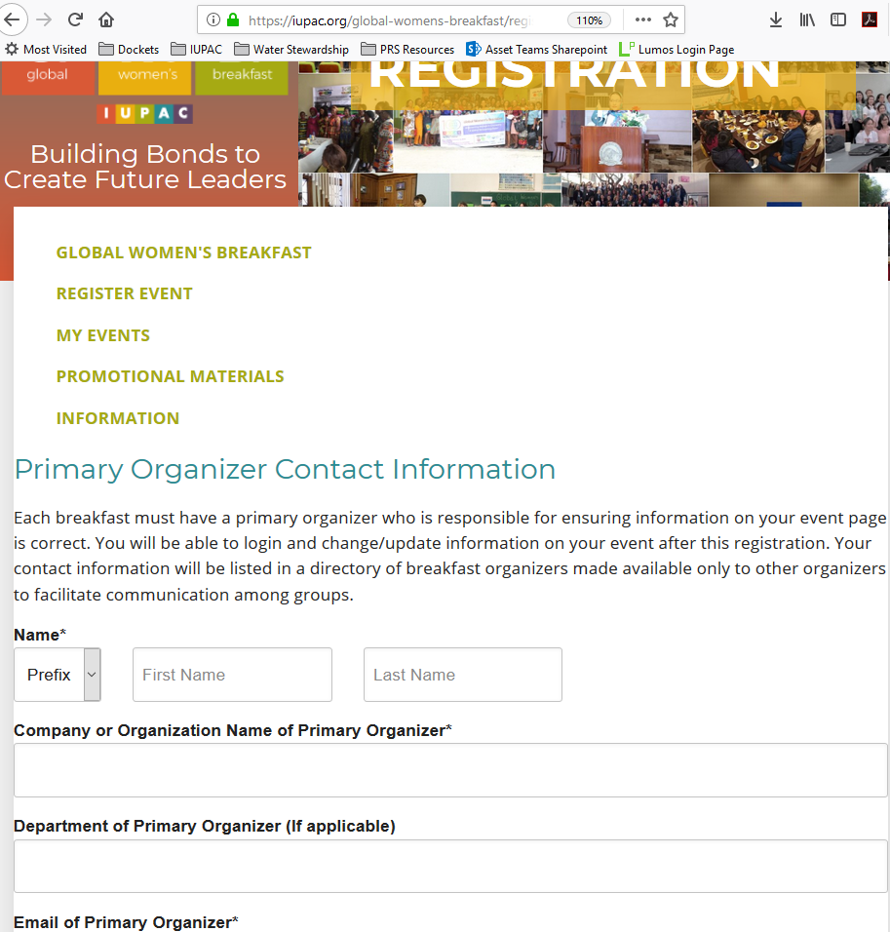

You will then be asked to sign in with your email address and the password that you entered in the form.

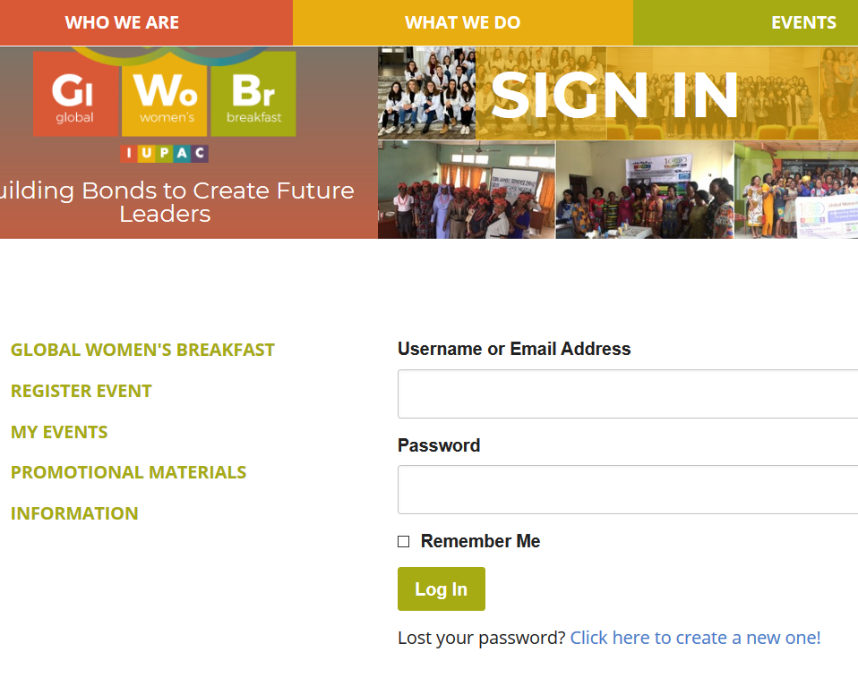

You can then add your event into the system.

Then you fill out the information on your event and click submit. Most important are to enter the correct GMT timezone for your event location. If you are unsure, please go to https://www.timeanddate.com/ to check. The estimated start and end times of your event will be used to indicate on the global map when your event is active. The address of your event is also important so that it can be displayed

